Database Development and Class Registration

Braden Abbey

CST 499: Capstone for Computer Software Technology

Amr Elchouemi

10-24-2022

When it comes to making a course enrollment system we need to set up a few things. Our database and tables need to be set up in order to push information to it and pull information from it. We will use our database for log in information as well as class and schedule information. If a class is full then we will be added to a waitlist until there is a spot open. When we add a class we don’t want we need to be able to drop that class as well. Below we will go through the build for the database and the functions of adding to schedule and dropping a class.

**Database Tables**

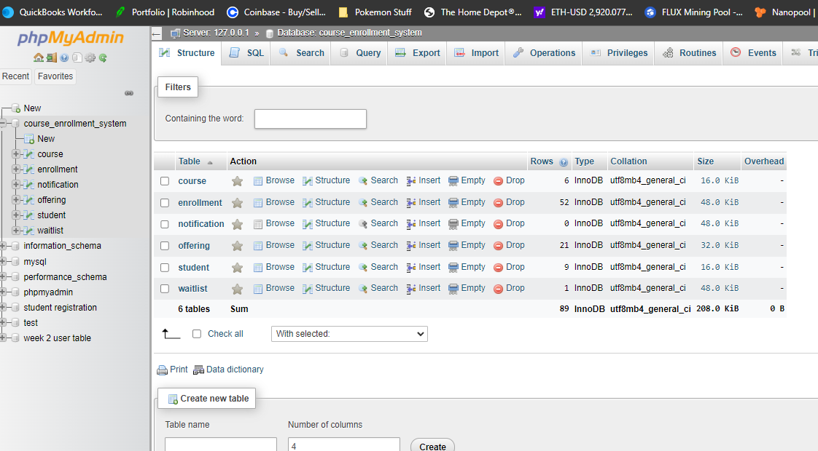

**Course table**

**Enrollment Table**

**Notification Table**

**Offering Table**

**Student Table**

**Waitlist Table**

**Landing Page Update**

**Search for Courses**

**Register for Course**

**View Schedule**

**Code Screenshots**

**Add Course**

**Add Course Continued**

**Register for Course**

**Functions.php file**

Experience Summarization

This week we were continuing from last weeks development and adding in more pages to our course enrollment system. The development phase is the writing of the program and includes all the coding and other processes (Jevtic, 2022, February 9). Also in this phase we are to make use of access control and source code management applications. When it comes to building our course enrollment system I started by breaking these sections down into chunks. I took my feedback from week 3 and made a whole database consisting of the different tables I would need for adding in log in information as well as course details. So to start I added my links on my landing page for register for course, search available courses, and view course schedule. I then used some test data to populate my SQL tables. Once populated I moved on to coding the register for course page to pull from the offering table. I started my PHP code file off by adding in the functions.php file and then added in my dropdown boxes and headings as well as the submit button. My functions.PHP file has all the dropdown functions to pull the data from the correct table as well as the joins I used on enrollment and offering table. Inner joins are used to return records that have matching values in both tables and a left join returns all records from the left table and the matched records from the right table (*SQL Joins*. SQL joins, n.d.). Then once you choose from the dropdowns your selection of semester and year you hit submit and it takes you to the register screen to choose an available course. From here you will choose a course and hit submit and a message up top will let you know if you have been added or if youre on the waitlist. Then to return to the home screen just hit the home button. When it came to working on this weeks pages I did run into some snags along the way. At first I couldn’t get my dropdowns to populate correctly and it took a bit of research on joins and functions to get them working correctly. This week was very informational and very rewarding when I got the finished product working.

As we can see from my pages and code there was a lot that went into this weeks assignment. I spent a lot of time coding this week and doing research along the way, but it was very rewarding. When we are coding we need to make sure we are following best practices as well as making sure we have clean code. The course enrollment system is all set up for use by students and their schedules populate successfully.

**References**

Jevtic, G. (2022, February 9). *What is SDLC? Phases of Software Development & Models*. phoenixNAP Blog. Retrieved October 24, 2022, from https://phoenixnap.com/blog/software-development-life-cycle

*SQL Joins*. SQL joins. (n.d.). Retrieved October 24, 2022, from https://www.w3schools.com/sql/sql_join.asp